MORNING ORDER OF SERVICE
Opening Praise: “White Flag”
Welcome/Announcements
Greeting: “Sunshine in My Soul” 430
Offertory Hymn: “My Faith Has Found a Resting Place” 412
Offertory Prayer: Lynn Corn
Praise and Worship: “Thank You”
“Jesus Is All”
Special Music: Sybil Whitworth
Children’s Message
Message: I Surrender All (Genesis 22)
Invitation: “Turn Your Eyes upon Jesus” 320
Closing Prayer

EVENING ORDER OF SERVICE
Opening Praise: “We’ll Work Till Jesus Comes” 608
Welcome/Announcements/Birthdays/Anniversaries
Greeting: “Trust, Try, and Prove Me” 616
Praise and Worship: “Count Your Blessings” 644
Offertory Hymn: “There’s Something About That Name” 177
Offertory Prayer: Lynn Corn
Special Music
Message
Invitation: “My Lord, I Did Not Choose You” 289

FOR THE RECORD: July 24-Aug. 6, 2016
SS&SG: 51 AM: 80
Offering Needed for July: $16,705.75
Given in July (undesignated): $13,954.94
Spent in July (total expenses): $13,572.05
Current Designated Balance: $ 2,448.25
Current Undesignated Balance: $57,249.03
New Building Fund: $35,508.55
Last Week Offering: $ 2,889.57
Weekly Budget Requirement: $ 3,855.17

SCHEDULES
Preschool Volunteers AM: Jill R./Marsha C. PM: Chyrl R./Lena S.
Preschool Volunteers for Wednesday 8/3: Lynn F./Lena S.
Volunteers for 8/7 AM: Billy S./Tracey G.

Children’s Church August Leaders: Paige C./Lynn F./Valerie E.
Children’s Church Helpers: Check Bulletin Board in Foyer

Van Driver: Rodney Eldridge Van Rider: Mike Bles

MISSIONS MOMENT

PRAY: For the Phillips family in Niger. Parker’s mother fell and fractured her hip so they flew back to the states to help care for her. Mark and the children went back to Niger to host a mission team from the USA.

PRAY: For the mission teams in El Salvador who are doing optical and medical clinics and VBS this week. They will return on August 6.

PRAY: For the work at the Jerusalem Prayer Center. Many of the religious leaders in Jerusalem are facing serious medical problems. Pray that God will be glorified as non-believers witness the strength of Christians in difficult times.

PRAY: For the members of FBSC as we are called to be “salt and light” in Scott City and neighboring communities. The harvest is white and ready for a harvest. Pray that God will send us to gather the harvest to him.

PRAY: For wisdom to make the right choices for the leadership of our county, state and country beginning with the primary elections this week.

GIVE: Bring your shoes, food for the food pantry, bottle caps, etc. to provide for the basic needs of those in our community and around the world.

GIVE: As God leads you to give and offering. Did you know that an offering is what you give after you give your tithe?

GO: Across the street, next door, or across the ocean when God calls you to meet a need and share the faith you have as a Christian.

Can you really call yourself an Acts 1:8 or Great Commission Christian without a passport? Why don’t you step out on faith and apply for a passport soon? You will need one to go with others to North Italy next spring, or wherever God calls you.

‘Till He Comes,
Kathy Blevins/Missions Director

Contact Us:
1102 2nd St W / PO Box 4217
Scott City, MO 63780
(573) 264-2214
Secretary-fbc-sc@sbcglobal.net
www.firstbaptistscottcity.org
Facebook: First Baptist Scott City

July 31, 2016
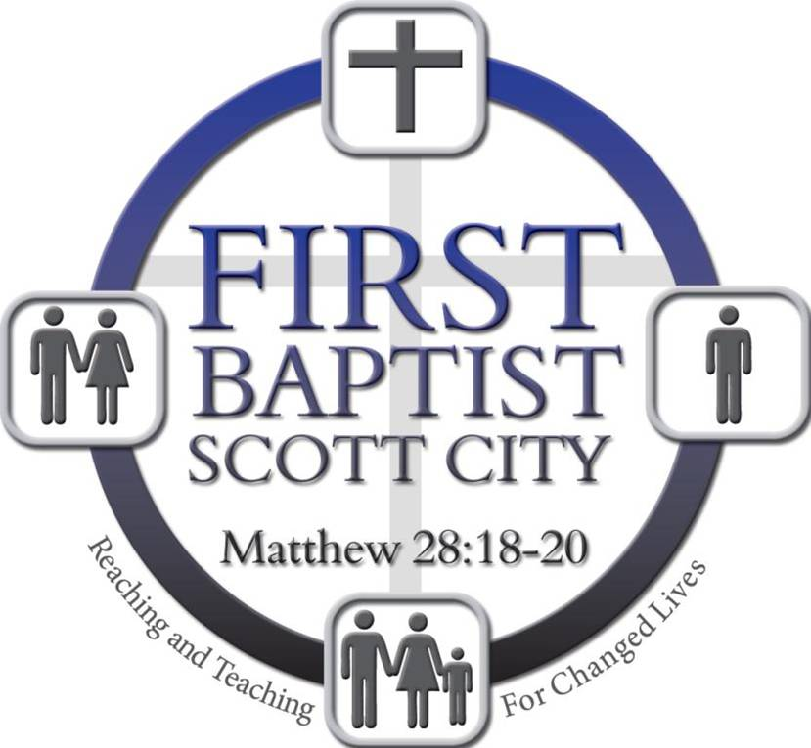

WE’RE GLAD YOU ARE HERE
Whether you are a regular member or a first-time guest, we are glad you have come to First Baptist to worship our Lord and Savior Jesus Christ. First Baptist strives to be a friendly church that is passionate about helping one another grow in the grace and knowledge of Jesus.
If this is your first time at First Baptist or if you have not been in a while, we hope you are blessed by the warm reception, Christ-honoring music, and biblically-based sermon. Please fill out a guest card in the pew in front of you and put it in the offering plate. God Bless. --- Pastor Jeremy.

OPPORTUNITIES THIS WEEK

SUNDAY, JULY 31, 2016
9:45 A.M. Sunday School
10:45 A.M. Worship Service
5:30 P.M. Children’s Church Supper
6:00 P.M. Children’s Church
6:00 P.M. Youth Group
6:00 P.M. Worship Service

TUESDAY, AUGUST 2, 2016
6:30 P.M. Women’s Bible Study/Forgiveness

WEDNESDAY, AUGUST 3, 2016
7:00 P.M. Prayer Meeting
7:00 P.M. Children In Action
7:00 P.M. Mission Friends
7:00 P.M. Hooked 419

ANNOUNCEMENTS

If your child has a VBS SUBMERGED CD, please return it to Lynn Felton or Cheryl Corn and it will be replaced with a Music for Kids CD.

The TECH TEAM is looking for more volunteers to serve in the booth on Sunday mornings. We will train anyone who has a little experience with music players and/or computers. The program we use for the screen is called ‘EasyWorship’ for a reason. Must be at least in 7th grade or older. Also, we would like some adult volunteers as well. Anyone who is interested please speak with Uriah Kiehl.

If anyone wants a copy of today's service, please speak to someone in the booth and we will get you a copy as quickly as possible.

Two more CHILDREN’S CHURCH TEACHERS are needed. If you are interested in helping, please speak with Lynn Felton.

There are families in our church and from our children’s church program that need help purchasing SCHOOL SUPPLIES. We are collecting donations to help purchase needed items. If you feel led to give, please notate on your check or envelope “school supplies”. If you have any questions, please see Lynn Felton.

ITALY MISSION TRIP INFORMATION
Two trips are being planned for 2017. The first will most likely be next Spring, with the second trip being in the Fall. For more info on the Italy Missions Partnership, pick up a booklet from the foyer table.

ONGOING COLLECTIONS
(collection tubs are in the back foyer)

FOOD PANTRY: Canned food and non perishables are always needed.

SHOES FOR WATER: Gently used shoes help pay for wells in Kenya.

BOX TOPS FOR EDUCATION: This program provides .10¢ for every box top redeemed. Please put box tops in the can in the front foyer.
OPTIONS FOR WOMEN/HELP FOR FAMILIES: Prairie Farms’ containers have stickers with a code underneath that is redeemable for .05¢. Put caps in the foyer basket and we’ll redeem the codes for you.

PRAYER REQUESTS

MILITARY: ANDREA GRAY (Tasha Cummins)
JEREMIE JAMITO (Jeff and Sharon)
AUSTIN LAUNIUS (Carly Howell)

NURSING HOME MEMBERS:
Cape: GREG ALLEN; MIKE BOSWELL; NORMA FOY; MAXINE HILL
DON JOHNSON; HAL PHILLIPS; GLORIA FAYE WADLINGTON

Chaffee: CARLENE GILLILAND; LOREAN KNUPP

Dexter: KATHERINE ROBINSON (Bessie Riggs)

HOMEBOUND: DAVID LUDWIG (Connie R); CONNIE RECORD

CANCER CONCERNS:
GEORGIA ADERS (John Owens) REVA BURK (Vicki Lange)
*MYRON CARTER KATHY CUPPLES (Jeremy Sells)
TINA HUEY (the Hueys) KRISTA PITTLES/ovarian (Sharon Jamito)
LISA THOMPSON (Mary Hartle) MIKE WEBB (Vicki Lange)

HEALTH PROBLEMS:
*FRAN LOCKHART/recovering from brain surgery (Rodney Eldridge) WANDA NELSON; DEBBIE SCHRUM/possible surgery (Lynn Felton) *CHARISSE SLADEK/test results (Donna Corn’s daughter)

OTHER NEEDS AND REQUESTS:
*JIM & KATHY BLEVINS/on a Mission Trip in El Salvador.
Pray for the 2017 Spring Italy Mission Trip.

* = New or Updated = Passed Away
Format: PERSON NEEDING PRAYER/brief explanation (person requesting prayer). Requests are deleted if not updated.

*FBSC’s PRAYER WARRIOR TEAM is ready to join you in prayer. Call 264-2984 (Ruthanne Crook) with a prayer request to activate the prayer team on your behalf.
If you want your prayer request to go in the bulletin, please let the P.W.T. know, or submit your prayer request separately by calling Connie Sharrock (FBSC/264-2214) or email: secretary-fbc-sc@sbcglobal.net or attend Prayer Meetings on Wednesday nights at 7 pm.

